**What is Jira :**

**Jira is a proprietary product developed by Atlassian that allows bug tracking, issue tracking and agile project management. Jira is used by a large number of clients & users globally for project, time, requirements, task, bug, change, code, test, release, sprint management.**

**Planning and Scheduling tasks**

**Tracking Progress and reporting on issues**

**Managing their work**

**Software Development Team**

**Managing a Marketing campaign**

**Tracking a team work**

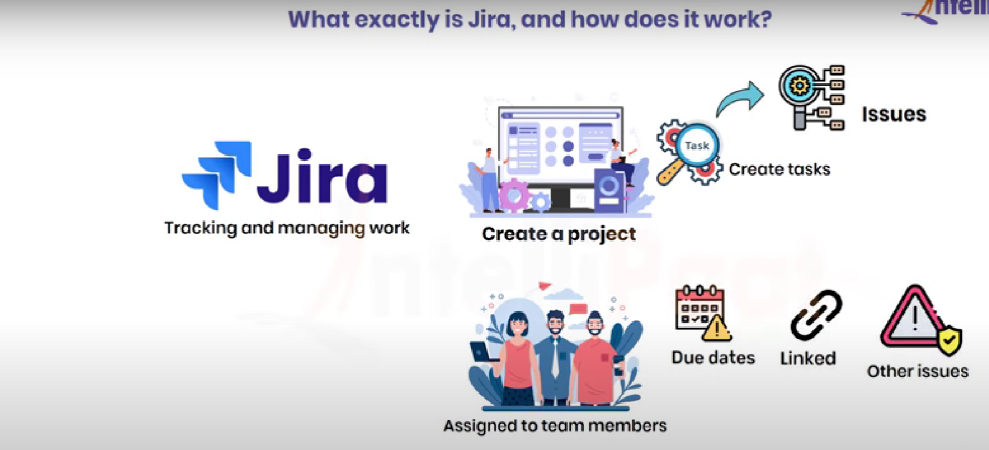

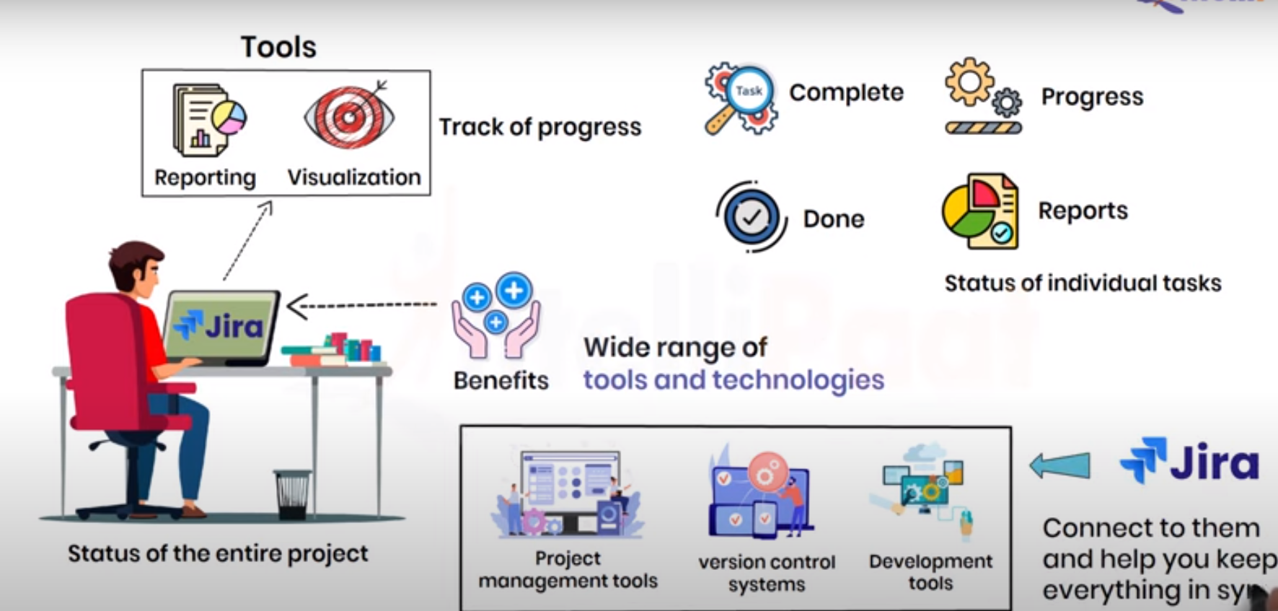

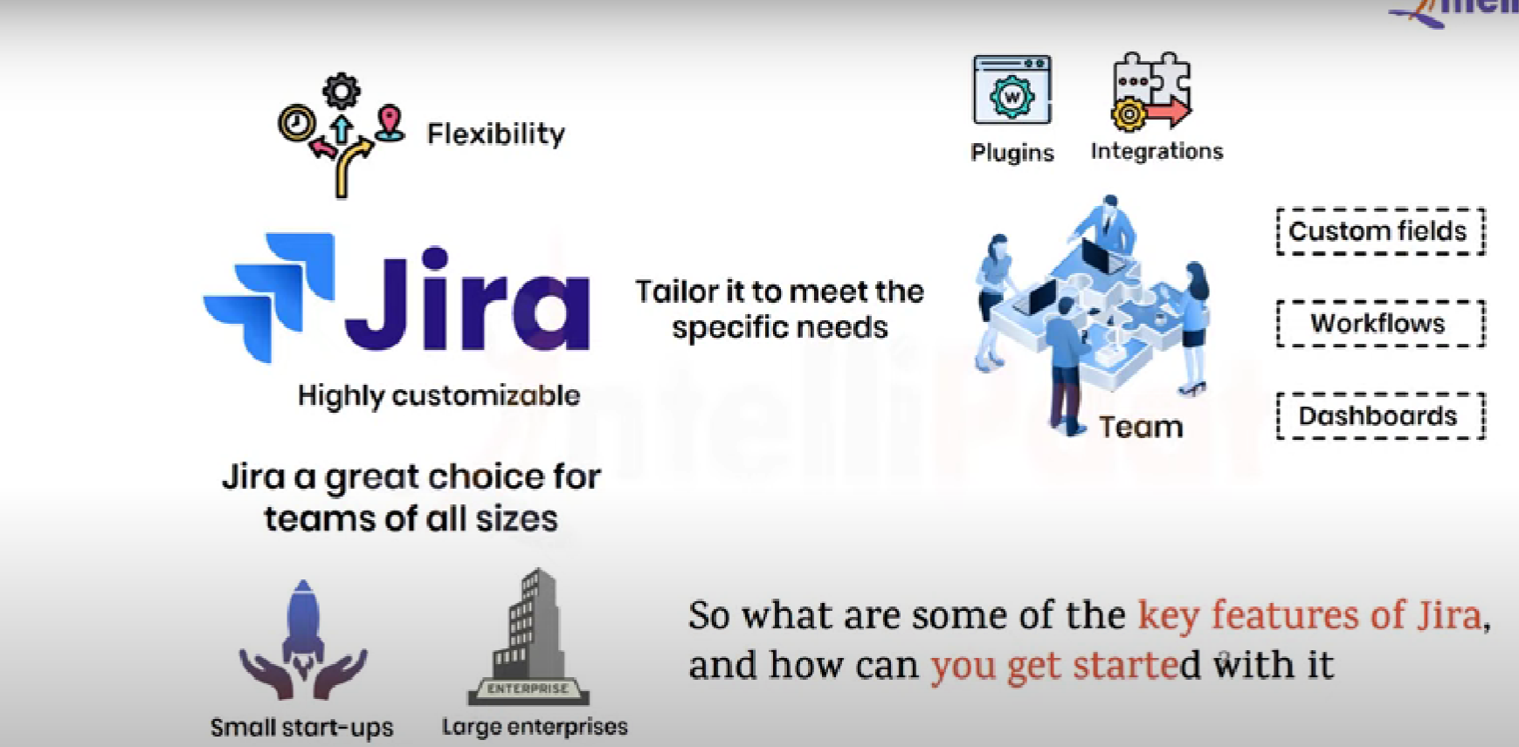

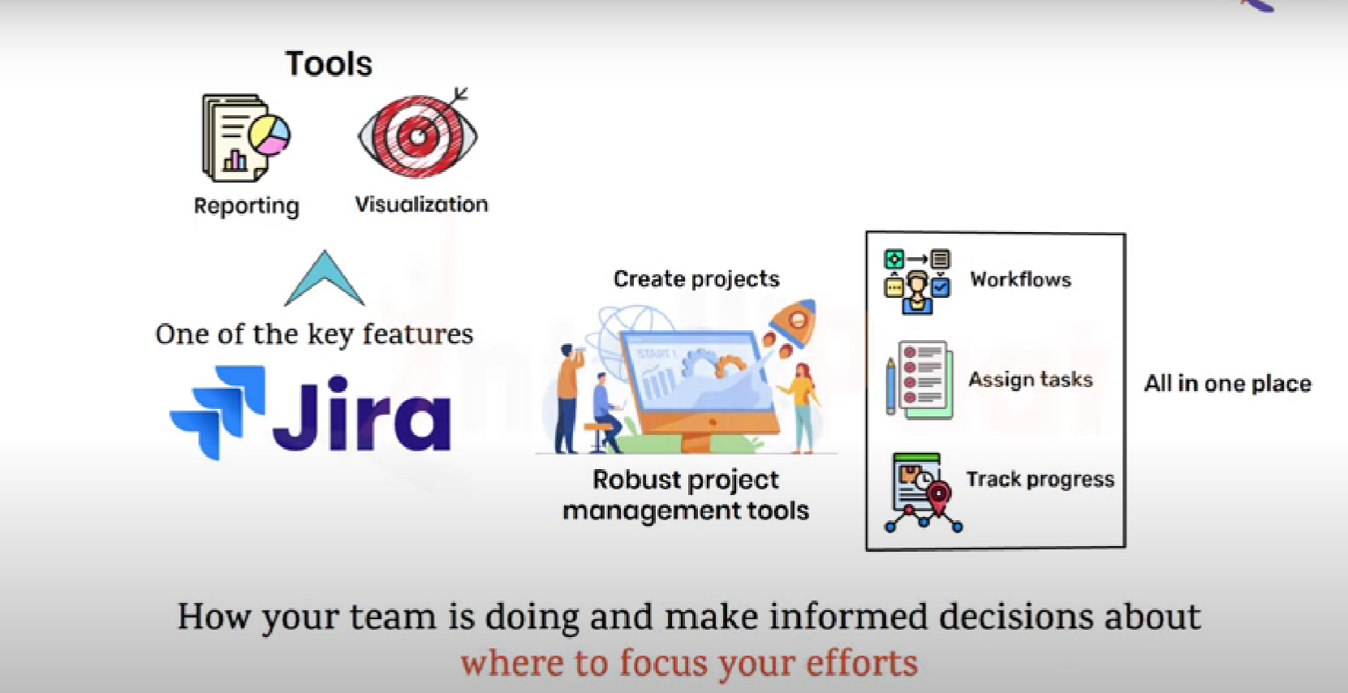

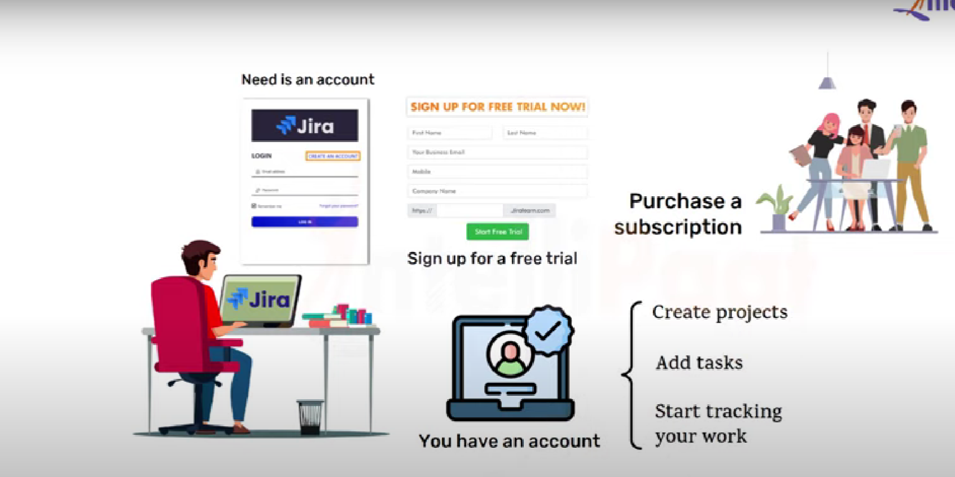

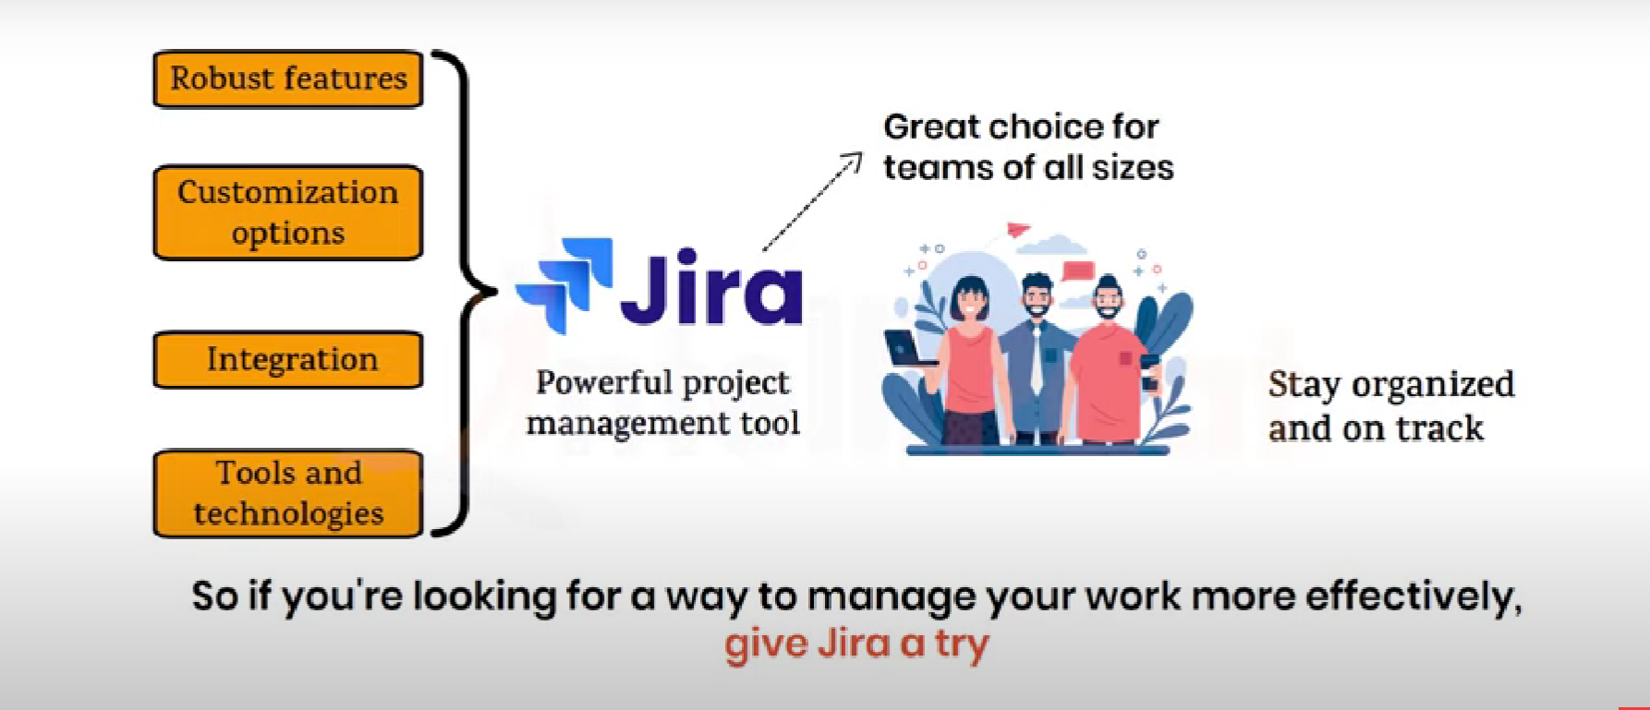

**Scrum Roles :**

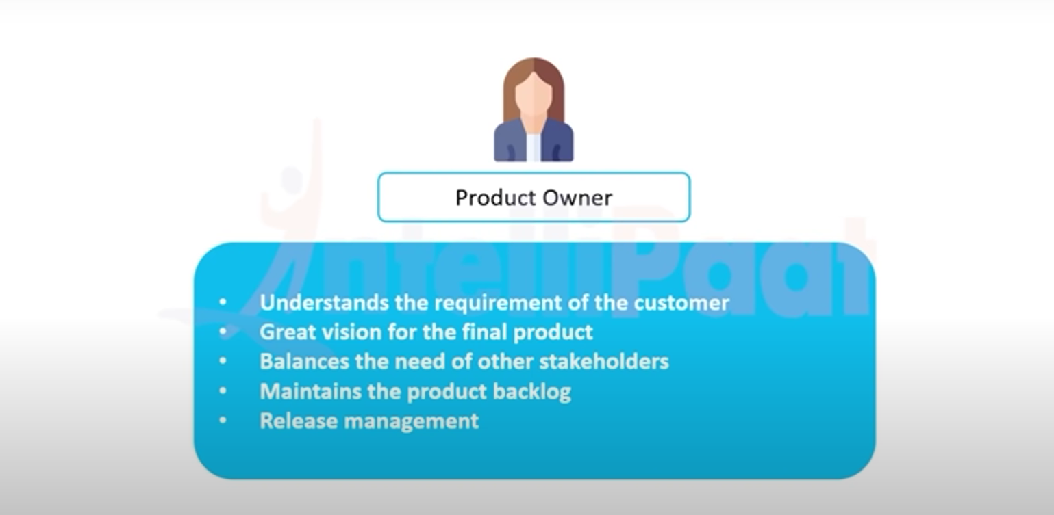

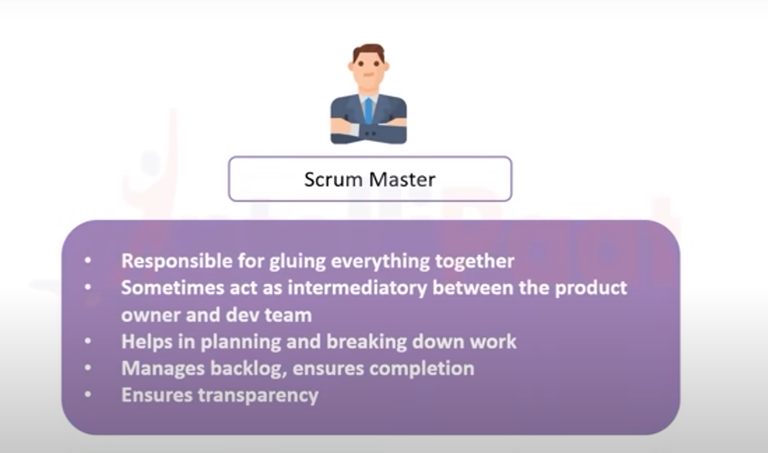

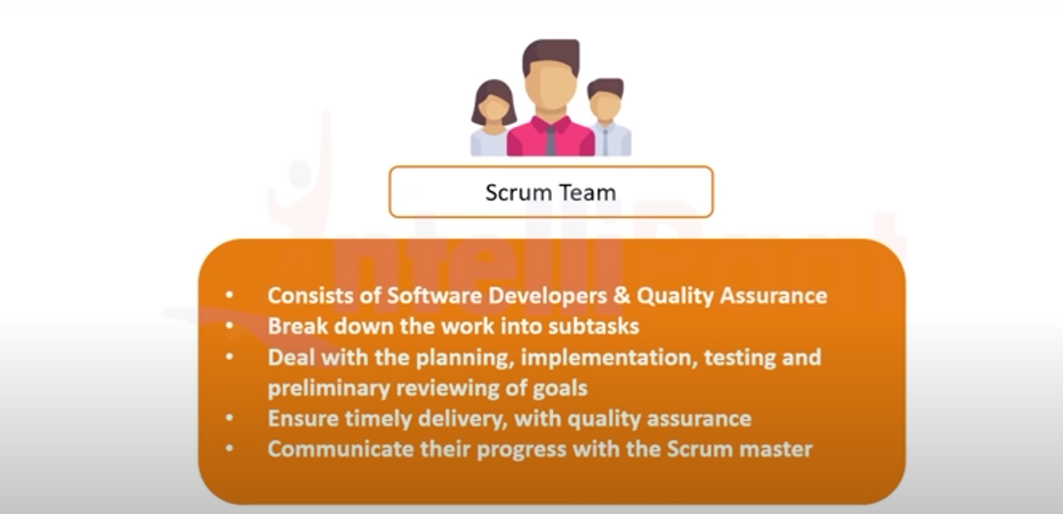

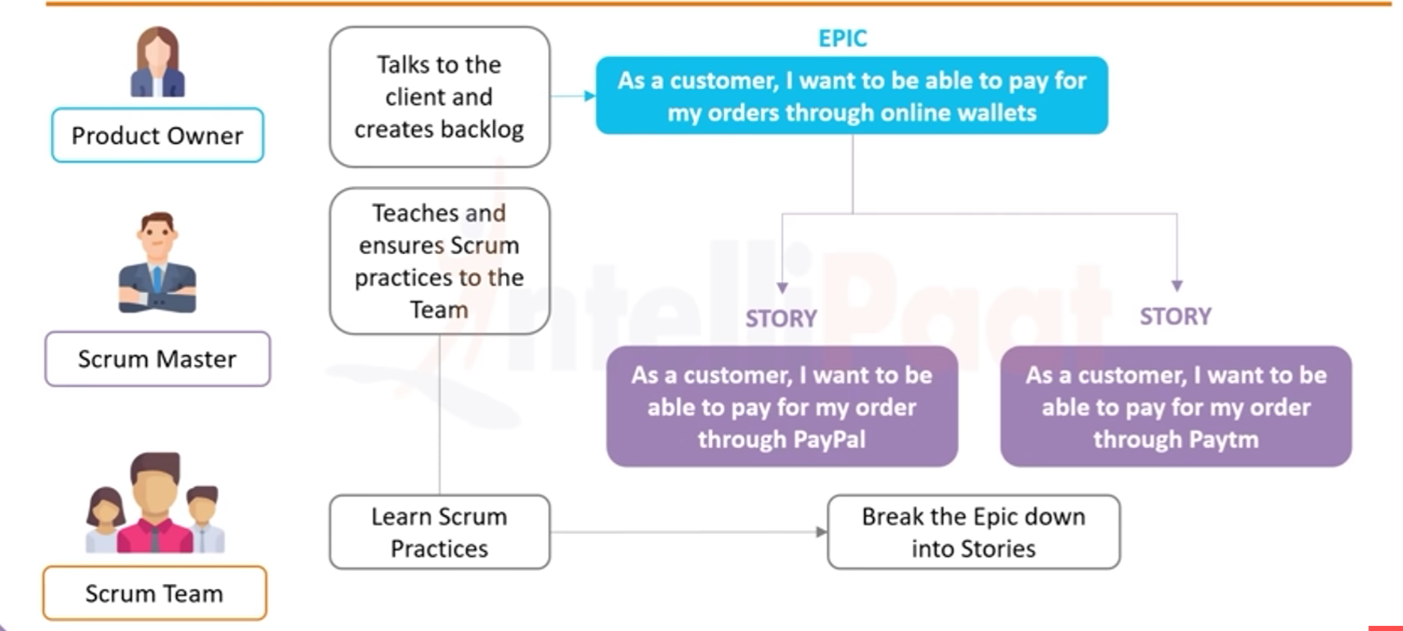

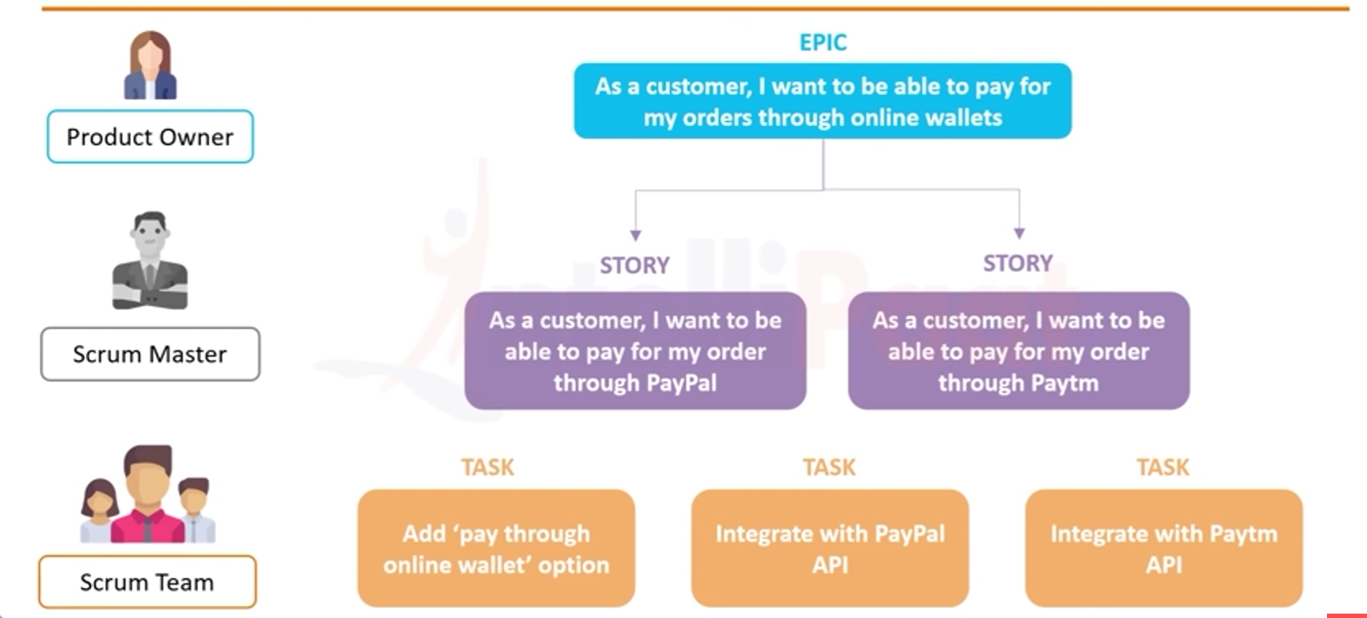

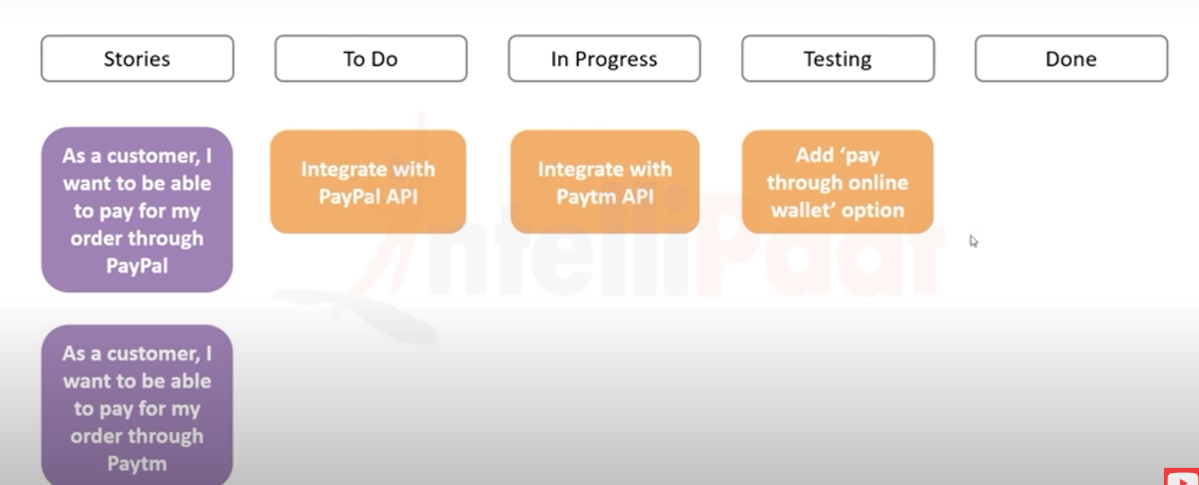

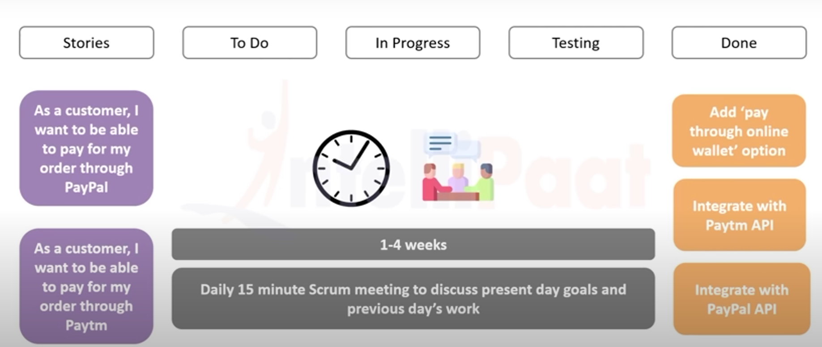

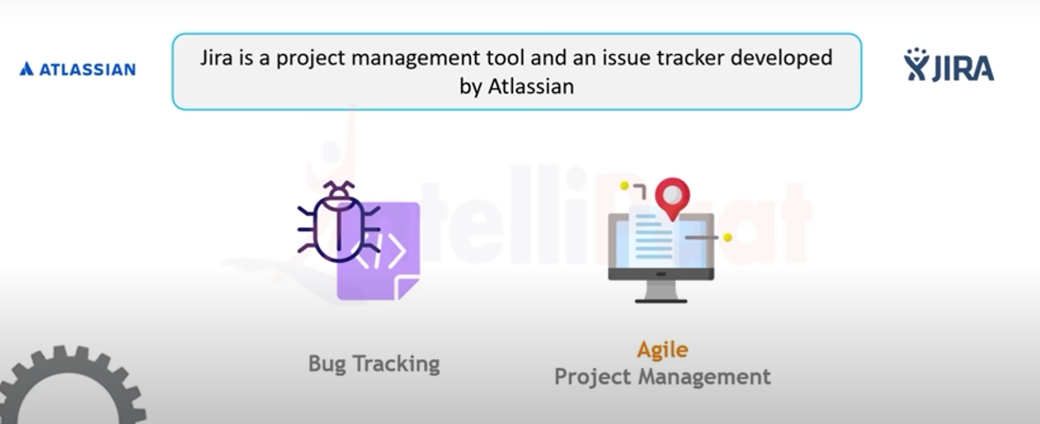

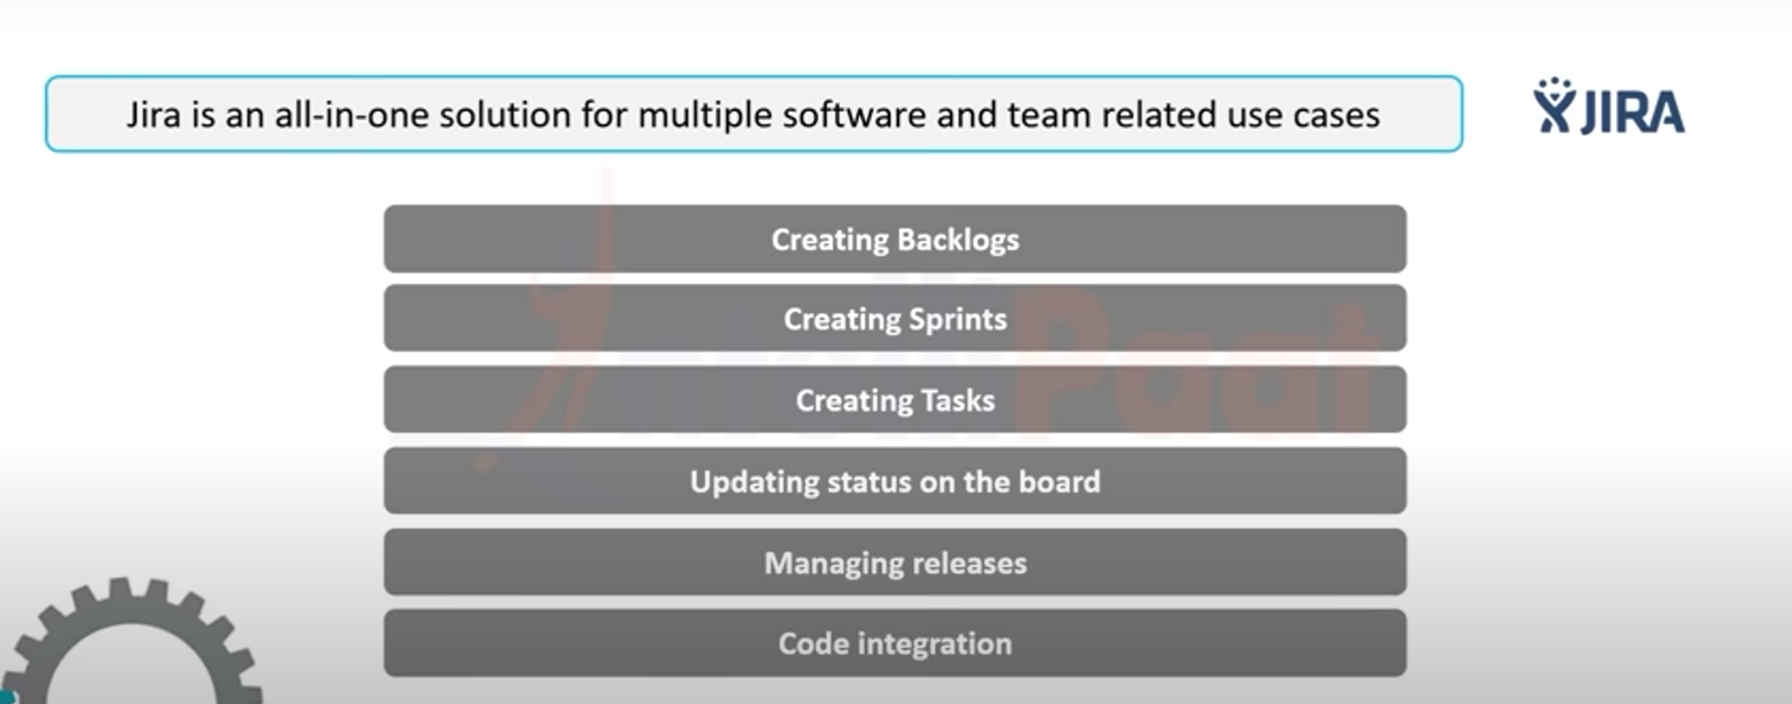

**Globally, tens of thousands of software teams depend on Jira Software to plan, track, and ship their work.**

**This product roadmap encompasses where our customers tell us they are going next, and the features we need to build to help them get there.**

**A vast majority of agile teams utilize the scrum and kanban templates, and within these templates, have a choice about how they are administered.**

**Company-managed tempates are setup and maintained by Jira admins, and ideal for teams who work with other teams across many projects in a standardized way.**

**Kanban is a project management framework that relies on visual tasks to manage workflows, while scrum is a project management framework that helps teams structure and manage their work through a set of values, principles, and practices. Agile is a set of ideals and principles that serve as our north star.**